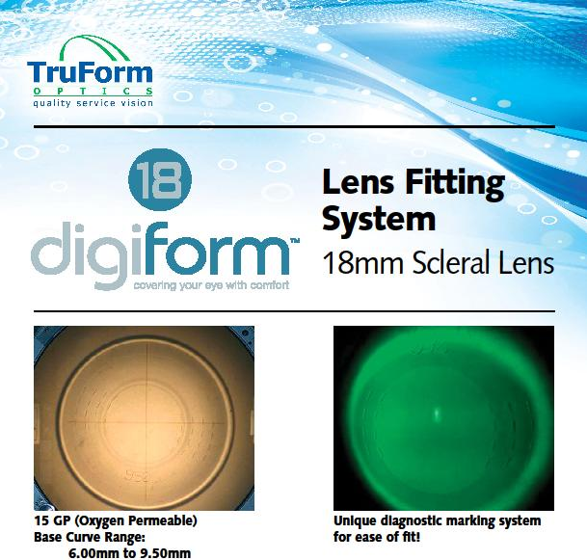
- Choose Initial Base Curve recommended from fitting set. Base curves are on the cases as well as laser etched on the lenses themselves.
- Apply Lens- Fill the bowl with saline solution and add ample fluorescein. Form a trip with fingers or use a plunger. With the patient’s head horizontal to the floor, slide the lens under the upper lid and then position under the lower lid.
- If there are no initial bubbles or harsh bearing areas, allow the lens to equilibrate for 20-30 minutes before evaluating. Evaluate the tear film under the lens especially at the laser etched zones. The markings are 8mm (optic zone), 10mm, 12mm, and 14mm. Note any areas that need more or less clearance and order expressing in mm, diopter, or micron values. The areas may be changed 360 degrees or quadrant specifically.
- Perform over refraction.

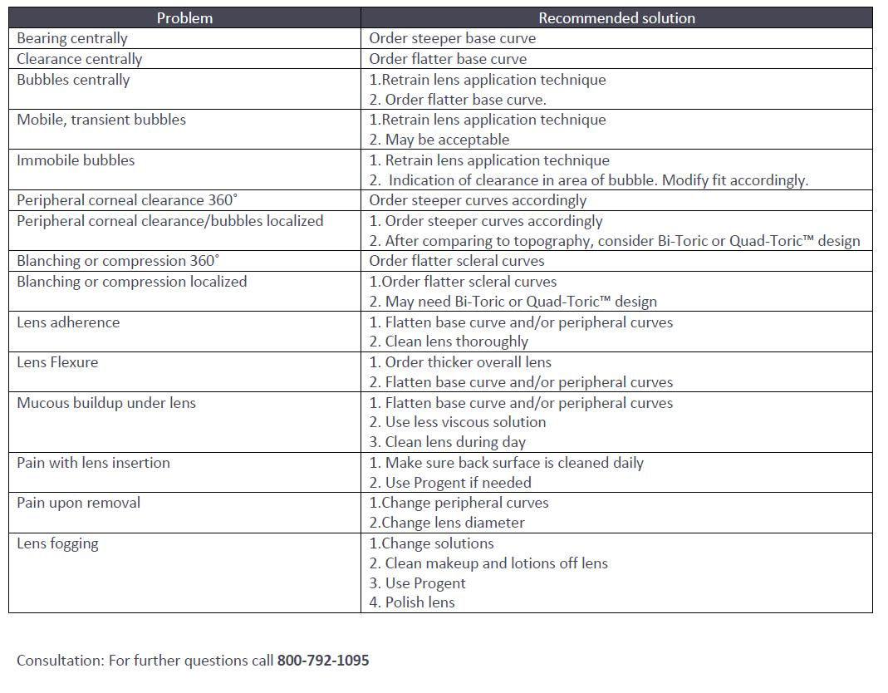
*photo courtesy of Dr. Halina Manczak

